Title of Abstract: Joint ECTI and ASEAN UEC Workshop 2022
Author Name¹, Author Name², and Author Name³
Affiliation 1, Affiliation 2, and Affiliation 3
Author 1 e-mail, Author 2 e-mail, and Author 3 e-mail

Abstracts contain a brief description of the problem and research objectives, the method used, and the results of the research. The abstract must be written in English and should be typed in MS Word.doc format and converse to be pdf file before uploading in the abstract submission system, using 10 size Times New Roman fonts, single-spaced on A4-size paper, the abstract is limited to 2 pages.

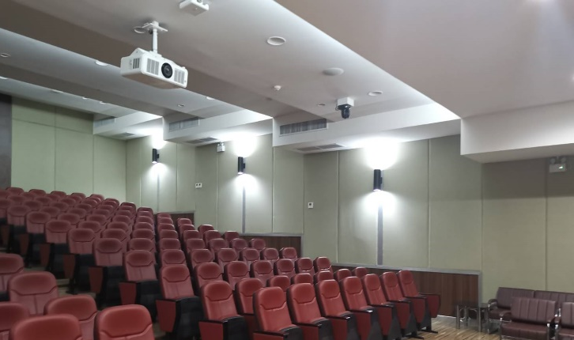 | 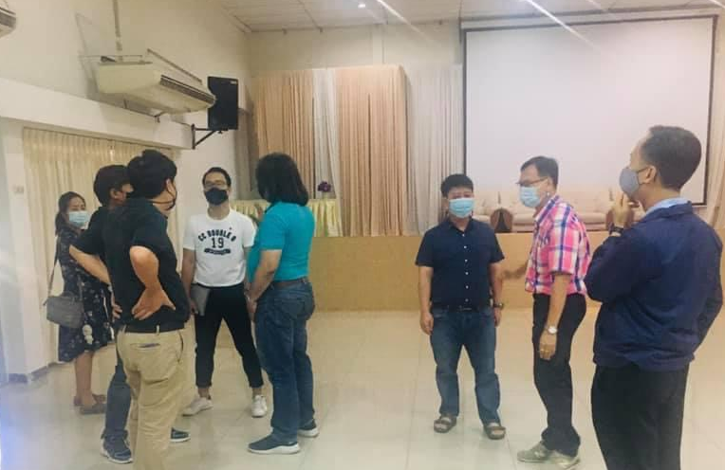
Fig.1: The places of our conference, the joint ECTI BEC and ASEAN UEC Workshop 2021

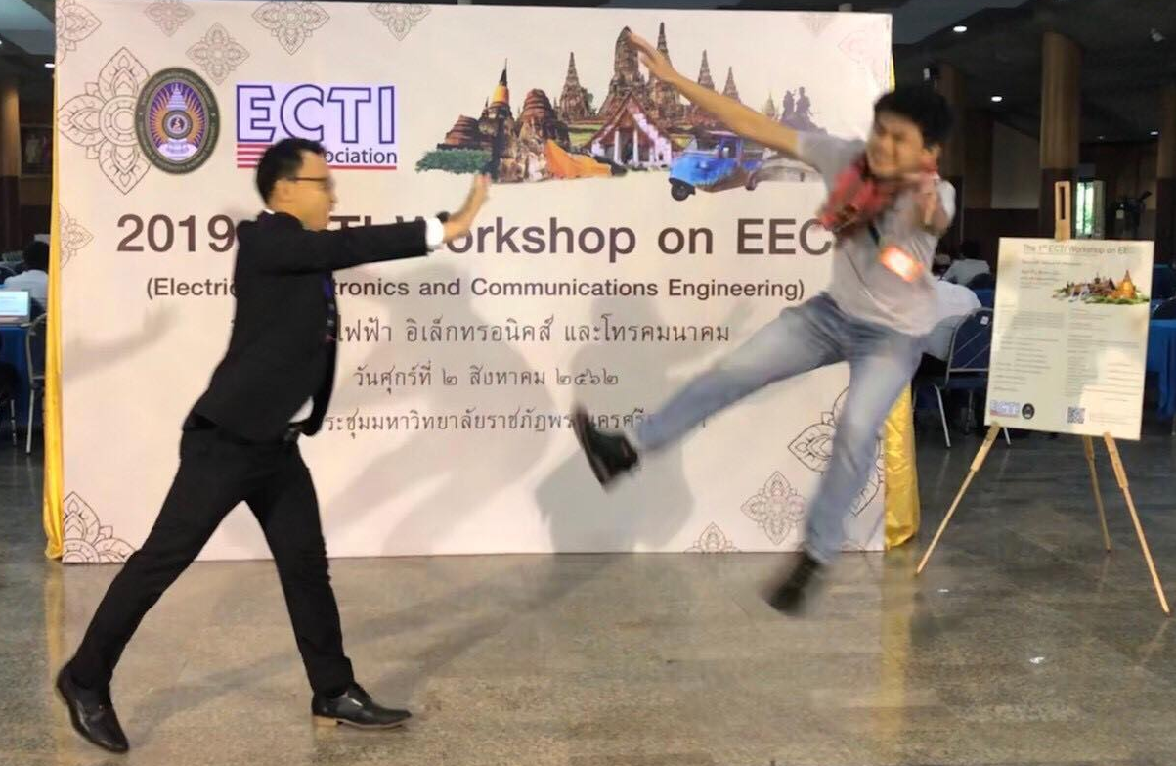 | 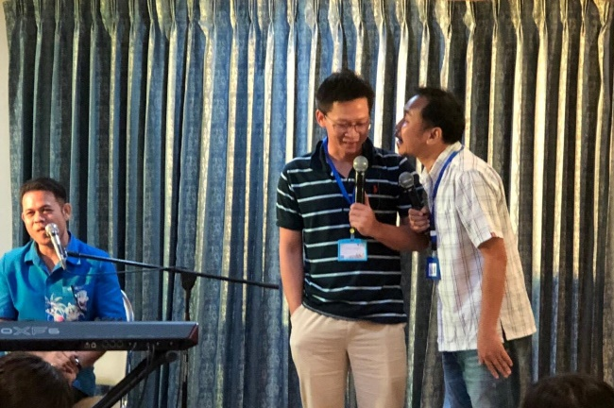
Fig. 2: The 1st ECTI Workshop 2019 at Phranakhon Si Ayutthaya Rajabhat University

